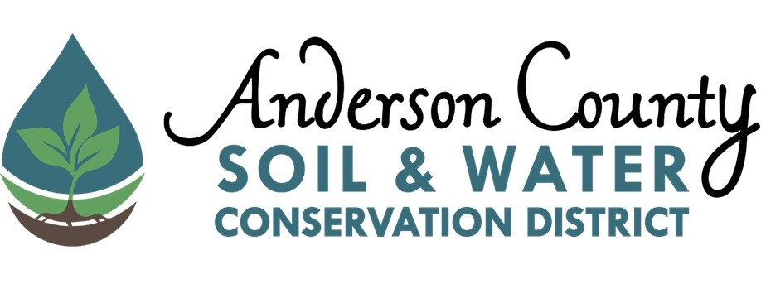
2026 Conservationist of the Year Award

Conservationist of the Year Award recognizes a person or organization that has had a positive impact or has been a good steward of Anderson County’s natural resources. This may include, but is not limited to, farmers, school groups, companies, industries, and civic organizations.

We would love to highlight their hard work and dedication to conservation by honoring them with an award from Anderson Soil and Water Conservation District. This award can be presented at your end of year celebration or awards ceremony at request.

Procedure:
Submit a brief narrative (500 words or less) describing the nominee’s qualifications and conservation related activities to the Anderson County Soil and Water Conservation District. You may include photos of the nominee or additional attachments as needed.

Award: Winners will be awarded a certificate and $100.

Deadline: March 27, 2026

Please contact Anderson County Soil and Water Conservation District if you have any questions or need further information.

