2026 Essay Contest
Rules:
The Essay Contest is open to any 5th – 8th grade student in Anderson County. Essays are the original work of the individual student and should be 500-750 words in length. Essays may be typed or neatly handwritten on the front side of the paper only. Only legible essays will be considered. Each essay should have the provided cover letter attached to the front, students' names should not appear on the essay itself. Each teacher must select ONLY the three best essays in his/her class for judging. If submitting essays from multiple classes of the same grade level, you are allowed to submit the 3 best essays from each class for judging.

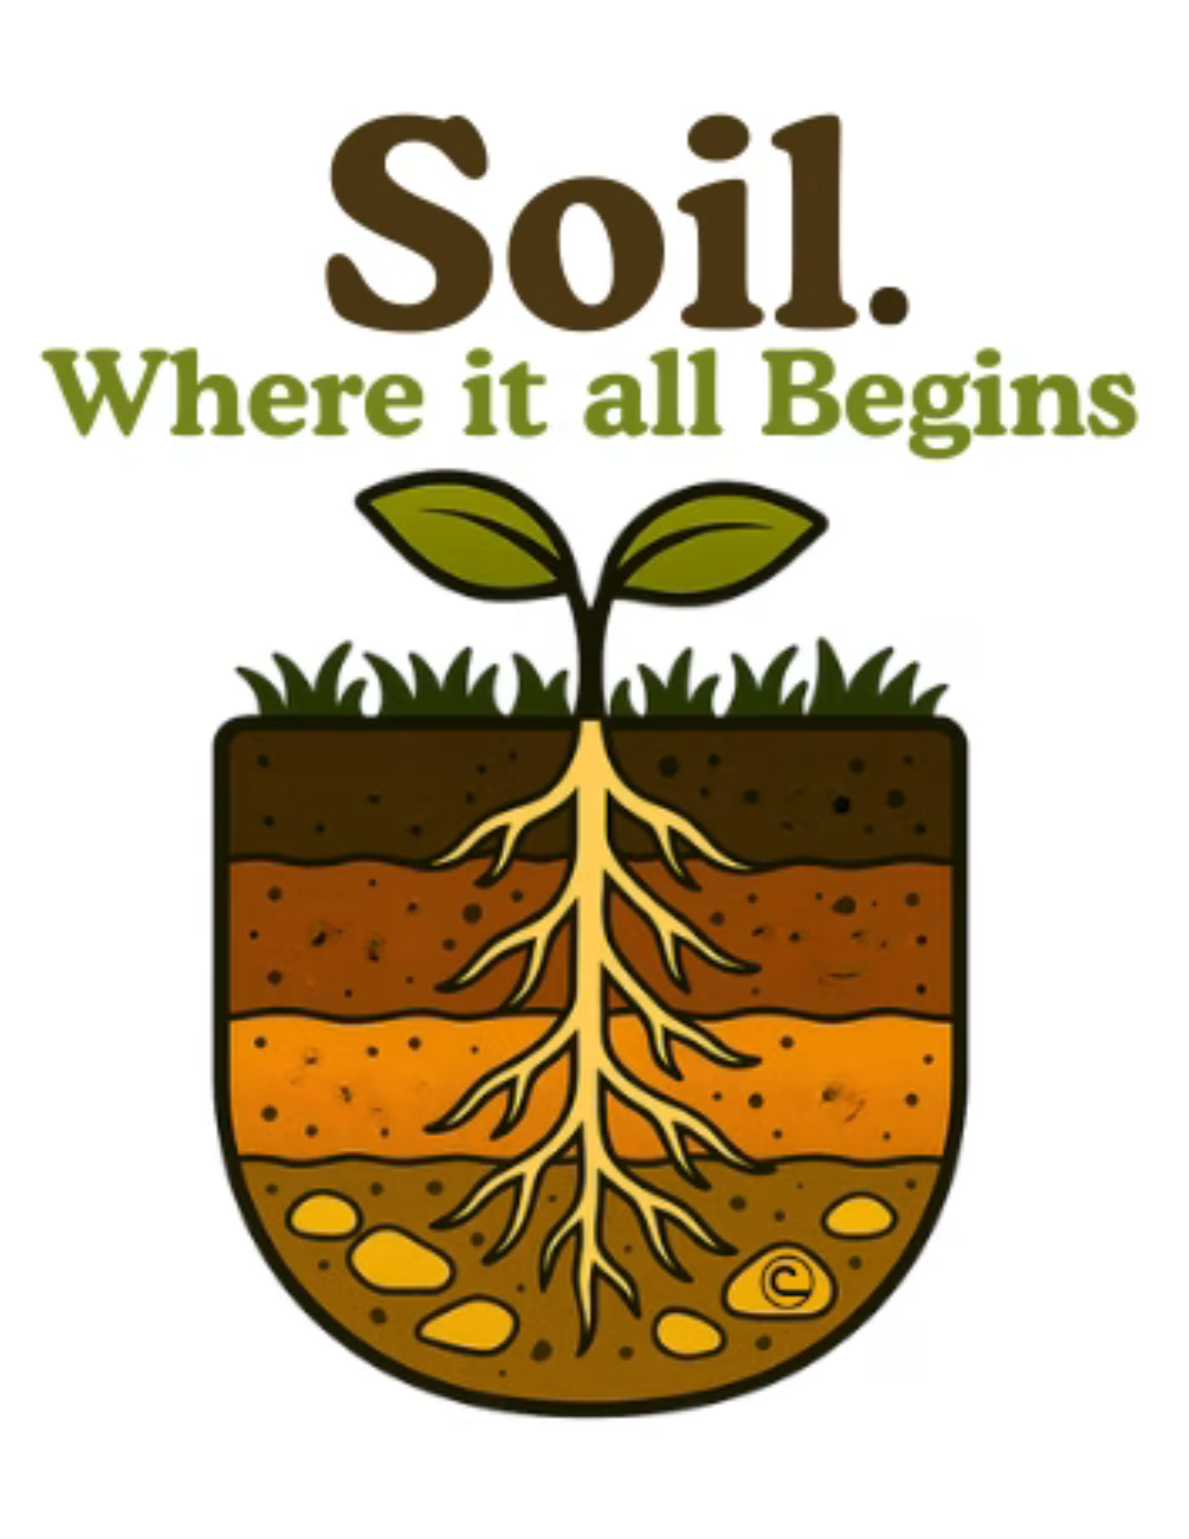
Topic Guidelines:
This theme celebrates the incredible power of soil to support life in all its forms. Soil is not just the ground we walk on. It is the starting point for healthy food, clean water, thriving habitats, and resilient communities. From backyard gardens to forests and city parks, everything begins with what is beneath our feet. Soil does a lot more than grow plants. It holds water, cycles nutrients, and provides homes for billions of living organisms that help keep nature in balance. It keeps roots in place, helps prevent flooding, and supports wildlife and people alike. The trees in our neighborhoods, the food on our tables, and the natural places we love all depend on healthy soils. When we take care of soil, we are taking care of everything it supports. That is why soil is where it all begins.

Write an essay that focuses on this topic and helps to explain why soil has such an important role in sustaining our planet. Be creative with your essay and if you need more resources on the topic, visit the NACD website Stewardship Week - NACD (nacdnet.org)
Prizes: Winners from each grade level will be awarded certificates and monetary prizes.
1st Place: $75
2nd Place: $50
3rd Place: $25

Deadline: Friday March 27, 2026
All essays should be received at the Anderson Soil & Water Conservation District office by the deadline. This can be via email or hard copies. Please contact Ann Marie Pauley if you have any questions or need further information.
2026 Essay Contest Cover Sheet

Student’s Name: __________________________________________________________

School Name: ____________________________________________________________

Grade: ________ Teacher’s Name: _________________________________________

Teacher Email Address: ____________________________________________________

Student Home Address: ____________________________________________________

Checklist (all items must be met in order to be judged):

Essay is my original work

Essay is between 500 – 750 words in length

Essay is typed or handwritten only on the front side of the paper

My name only appears on the cover letter, not on/in the Essay

