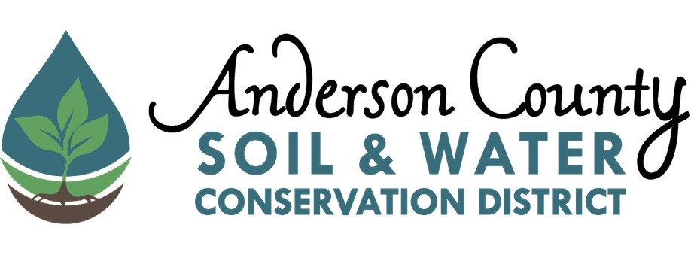
2026 Conservation Teacher of the Year Award

Conservation Teacher of the Year Award recognizes a teacher who has been actively working to advance environmental and conservation education. Awardee must be a teacher in Anderson County in public or private schools (including homeschool groups).
We would love to highlight their hard work and dedication to environmental education by honoring them with an award from Anderson Soil and Water Conservation District. This award can be presented at your school’s end of year celebration or awards ceremony at request.

Procedure:
Submit a brief narrative describing the teacher’s qualifications for this award including a list of his or her conservation education activities or programs to the Anderson County Soil and Water Conservation District. Candidates must be currently teaching K-12th grade in public or private schools in Anderson County.

Award: Teachers will be awarded a certificate and $100.

Deadline: March 27, 2026

Please contact Anderson County Soil and Water Conservation District if you have any questions or need further information.

