2026 Bulletin Board Contest
Rules:
The Bulletin Board Contest is open to any K-4th grade class in Anderson County. Bulletin board projects are a class effort and should include work of all students in the class. School groups such as science clubs, environmental clubs, or other after school programs are welcome to compete. There is no restriction on the size of the bulletin board.

Create a unique bulletin board outside your classroom (or inside) that showcases the theme of the year “Soil. Where it all Begins.” Be creative and inspiring!

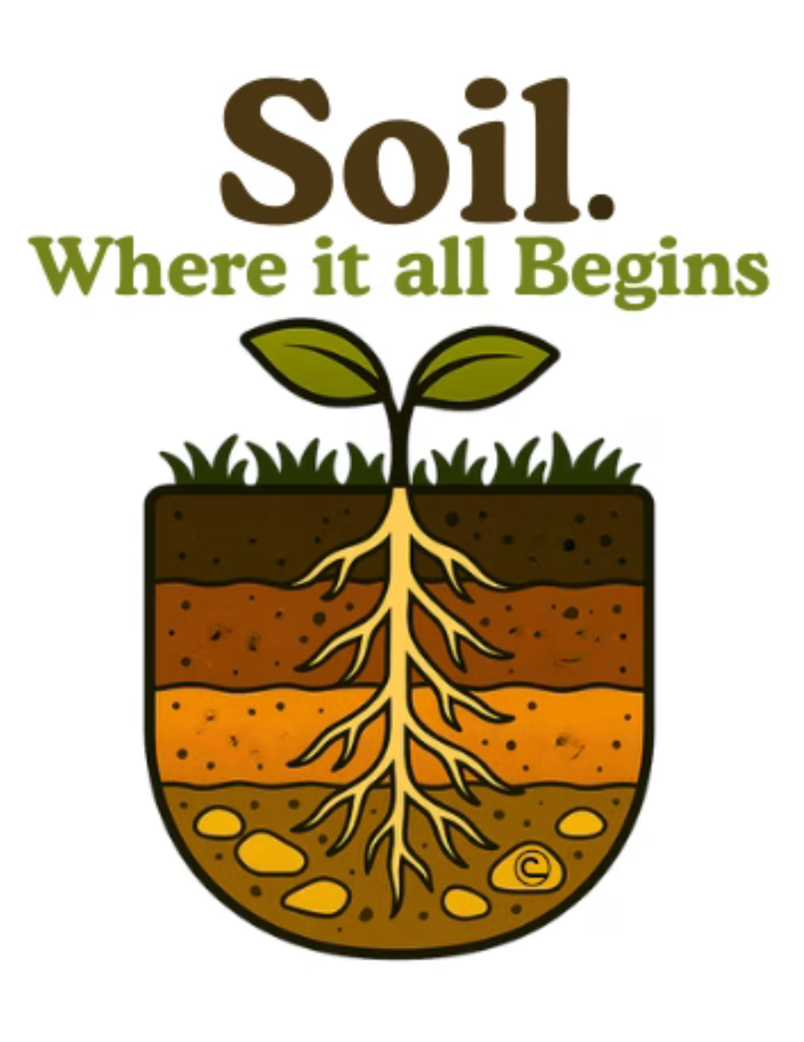
Topic:
This theme celebrates the incredible power of soil to support life in all its forms. Soil is not just the ground we walk on. It is the starting point for healthy food, clean water, thriving habitats, and resilient communities. From backyard gardens to forests and city parks, everything begins with what is beneath our feet. Soil does a lot more than grow plants. It holds water, cycles nutrients, and provides homes for billions of living organisms that help keep nature in balance. It keeps roots in place, helps prevent flooding, and supports wildlife and people alike. The trees in our neighborhoods, the food on our tables, and the natural places we love all depend on healthy soils. When we take care of soil, we are taking care of everything it supports. That is why soil is where it all begins.
Prizes:
One class/group will be selected, for an ice cream party, on a county-wide basis. Multi-grade groups (i.e. science clubs, etc.) will be judged at the highest grade level represented by the group. Winners will be contacted by ASWCD to set up a date for your ice cream party!

Deadline: March 27, 2026
All participating schools should contact the Anderson Soil & Water Conservation District office by March 13th to sign-up for a time to have their entries judged before the deadline. Please contact ASWCD if you have any questions or need further information.

